**Instructions created using Outlook 2013. This will also work with Outlook 2010.**

To Archive your Calendar items click on File in the top left corner of your Outlook window:

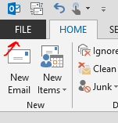

Click Cleanup Tools then choose Archive:

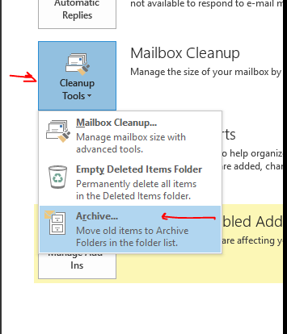

Select Calendar (#2) from the list under your Mailbox / Email address (#1), choose a date below that (#3 - Anything older than today can be archived), Check the box next to “Include”(#4), then click on Browse (#5). I have chosen to create a new Outlook Data file (.pst) and called it Calendar Archive (#6).

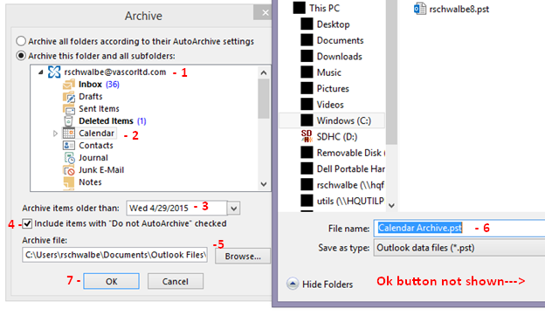

Click OK to save the newly created Calendar Archive PST file (Ok button not shown) then Click ok again (#7) to start archiving your Calendar.